Irish Indoor Bowling Association:
Sport Ireland Return to Safe Play Protocols

Resumption of Bowling under COVID19 Government Procedures
1. Club Responsibilities
1.1 Clubs should be fully aware and compliant with Government legislation https://www.gov.ie/en/collection/02cd5c-covid-19-information-resources/ as well as H.S.E. and Sport Ireland/Sport NI directives, and they should ensure that these guidelines are adhered to The Dept of Health have released a mental health document on 17 June 2020 https://www.gov.ie/en/publication/2e46f-sharing-the-vision-a-mental-health-policy-for-everyone/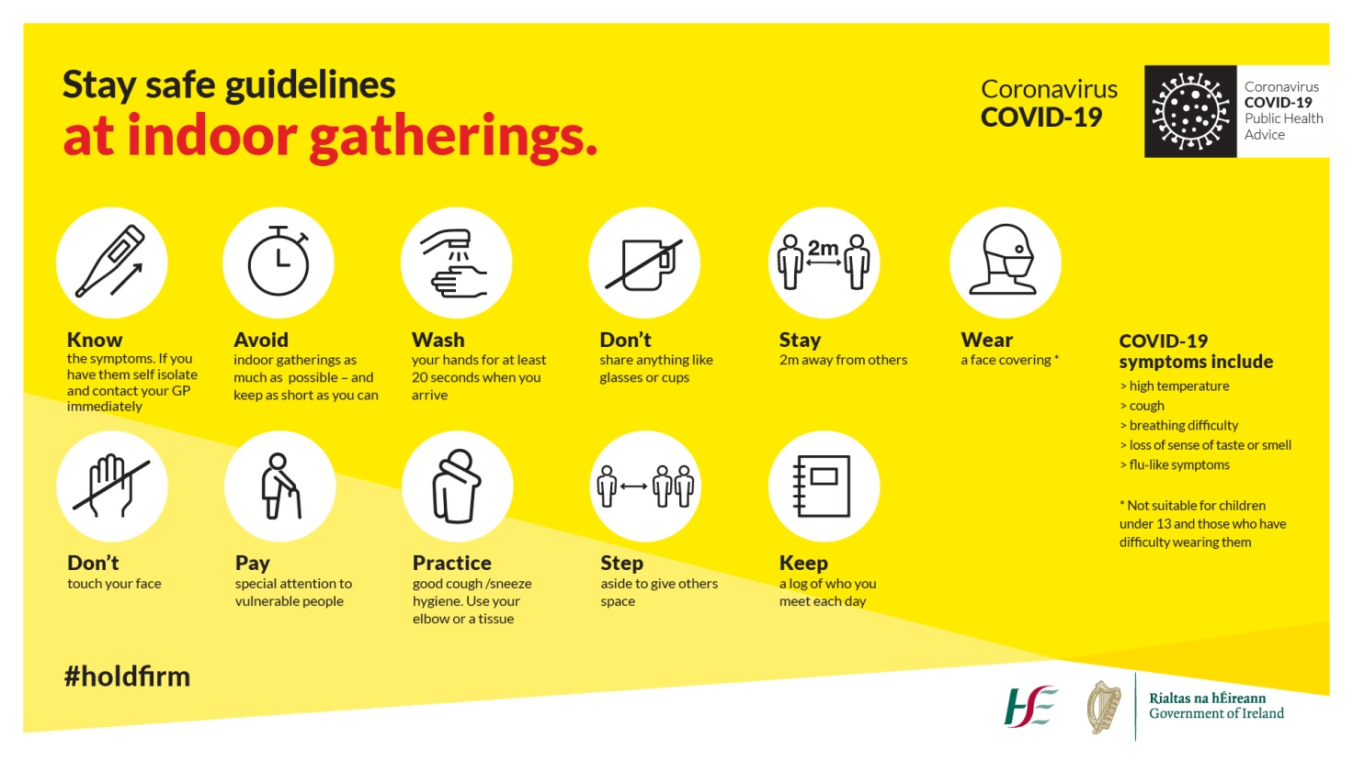.
1.2 Two club members will prepare the mats and playing equipment with hygiene in mind and disinfected for safe use by bowlers. This includes sanitising fenders, foot mats, block and jack on each mat. Mats should be laid at least one metre apart. After the game this equipment should be disinfected again before it is returned to storage.
1.3 Sanitisers are to be made available to all bowlers.
1.4 Toilets and hand washing facilities to remain open on club premises with all doors leading to them to remain open where possible. It is the responsibility of each club to ensure toilets are disinfected etc. as required. Tightly bag used tissues and put them rubbish bins provided. These bags should be put in another bag, tied securely and kept separate from other waste.
1.5 Clubs should appoint a designated COVID-19 Officer (see Appendix 1: Roles and Responsibility of a COVID-19 Officer and Appendix 2: Risk Assessment & Guidelines) who should maintain an electronic record of all persons in attendance for all sessions, with contact details. This will help to facilitate contact tracing in the event that a participant becomes ill with COVID-19. Attendance sheets should be completed by all individuals in attendance and stored in an appropriate manner in accordance with General Data Protection Regulation.
1.6 A designated should ensure that the information recorded in advance on the attendance sheet is accurate each session/activity
1.7 An electronic record/attendance sheet should include the below information:
Overall organisation details:
- Club/organisation/facility name
- Activities planned for session
- Location of activity
- Date of activity
Individual details:
- Arrival time
- Departure time
- Full name
- Phone Number
- Email address
- Club/Organisation
- Role/position within organisation (Attendee, parent/guardian, coach etc.)
2. Player Responsibilities
2.1 Player Health
2.1.1 All players who have tested positive/in isolation for Covid-19 or are living with a Covid-19 positive person will not be permitted on the premises of a bowling club and will be ineligible to do so until specific criteria are met:
i) If you have tested positive you may not return to bowling for a minimum of 14 days and at least 5 days without fever or any other symptom, as per government guidelines:
ii) If you are in self-isolation you may not return to bowling for 14 days or until you have returned a negative test and are symptom free, whichever is less, as per government guidelines: and
iii) If you are living with a Covid-19 positive person, you must also follow (ii), as per government guidelines.
Players who have symptoms should notify their club, if they were due to play, and start self-isolation for 14 days or until a negative test is returned and they are symptom free, whichever is the least amount of time. (See Appendix 3: Health Questionnaire for Club Members and Appendix 4: Club Ready Form).
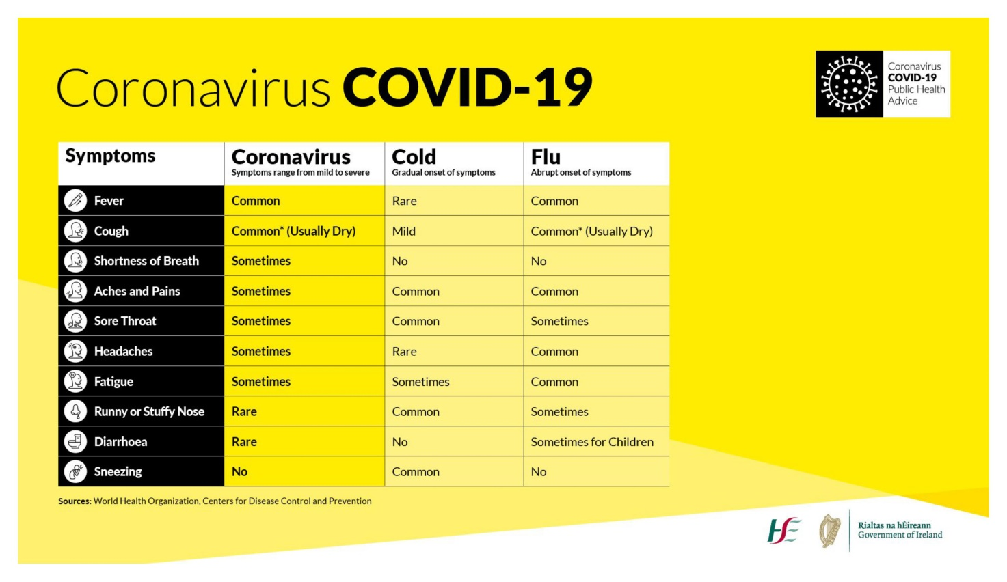
2.1.2 Ensure attendees enter via designated entry route. Ensure that this route is accessible for all attendees.
2.1.3 Players should put on a suitable face covering, either face mask or face shield, before entering the premises.
2.1.4 All players must sanitise hands upon arrival to a bowling premises.
2.1.5 Pregame and postgame handshakes and other gestures that involve contact with other bowlers are not allowed.
2.2 Attire and Equipment
2.2.1 Club attire for matches to be optional, bowling shoes will remain mandatory. This is the only item that bowlers should change on the premises.
2.2.2 Bowlers are allowed only one bag at the club attended.
2.2.3 Wash or sanitise your hands and sanitise any equipment (including bowls, jacks and mats) you use before and after you play – do not assume that the person before you has sanitised the equipment thoroughly.
2.2.4 Sanitise padlocks, keys and door handles before and after use.
3. On the Mat
Recommended numbers
Following the Government’s recent announcement on Covid-19 measures, Sport Ireland engaged with both the Department of Sport and the Department of Health to provide guidance and advice to sporting organisations on the practical implications of the new guidelines. The Guidance has been approved by the Department of Health and is available on the Sport Ireland website. https://www.sportireland.ie/news/sport-ireland-issues-practical-guidance-for-sport-on-covid-19-measures
A key item in relation to indoor sport is as follows: Organised Sports training within indoor facilities can do so in multiple pods of 6 once sufficient space is available and strict public health protocols are in place. The use of multiple pods (i.e. independent groups of 6 not interacting with one another) is assisting with minimising the number of people in a group while acknowledging that some facilities have the capacity to cater for larger numbers of people in a safe manner and within public health guidelines.
Ideally the 6 people will play on the same mat to minimise the chance of transmission. If it is necessary to move mats, then the new mat would have to be sanitised before play could recommence. Also depending on the frequency people are playing, it would be recommended to stay within the same ‘pod’. This is because if someone ends up being sick and has played in multiple different pods on multiple different days then the number of contacts has now increased than if they played within the same pod of 6.
The overall aim of the current restrictions is to limit the chances of transmission and reduce the number of contacts people have in their various social settings.
Please note that the numbers may change at any time in accordance with Government guidance.
3.1 Mat, Jack, Bowls and Scoreboard
3.1.1 Spray chalk to be the only way to mark bowls that have made contact with the jack.
3.1.2 A player will not have control of the mat until the previous player is at least 2 metres from the mat.
3.1.3 In the event of a bowl that has left the rink or gone into the ditch, the bowl is to be removed by one designated player and placed behind the fender using a cloth.
3.1.4 In the event of a no head, the jack is to be replaced by one designated player using a cloth.
3.1.5 Placing of the jack should be done by foot.
3.1.6 When a count has been decided, bowls to be removed either by the owner of the bowls or by removing them by foot.
3.1.7 All bowlers must have a cloth with disinfectant/sanitiser to apply to each bowl and jack before use. Where a person requests assistance with lifting their bowls, the person assisting will wipe their bowl, hand it to the player and return to their seat.
3.1.8 Measuring will be done by one player on each rink predetermined by skips.
3.1.9 One designated player to keep the scoreboard updated.
3.1.10 Scorecards to be updated and kept in the skips’ possession at all times.
3.2 General Social Distancing Guidelines
3.2.1 Each bowler will remain at all times at least two metres from all other bowlers.
3.2.2 Bowlers walking up and down to the head should using space to their left or by using vacant rinks available. Should an adjacent rink be in use and players are walking to and back from the head, you must wait for them to stop before walking to the other end of the rink.
3.2.3 Visits to the head are not permitted, except in singles play where a player may visit the head upon delivery of their 3rd bowl.
4. Spectators
4.1 The number of spectators will be restricted to Government guidelines.
To note: Nothing in these protocols obliges any member to play bowls. It is a matter for each person to assess their own risk.

